Lab 6:

- Illustrate CRUD operation using php.
a. Create a new table named students in your database with columns: std_id,
Student_name, RollNumber, marks_obtained, result(Pass/Fail).
b. Insert details of 5 students.
c. Display the result of 5 students in a table with buttons to edit and delete record
d. Edit the marks of one of the students
e. Delete the record of one student

Code
Database:
CREATE DATABASE student_db;

USE student_db;

CREATE TABLE students (
std_id INT AUTO_INCREMENT PRIMARY KEY,
Student_name VARCHAR(100),
RollNumber VARCHAR(50),
marks_obtained INT,
result ENUM('Pass', 'Fail')
);

#create_student
<?php
$conn = new mysqli("localhost", "root", "", "student_db");
if ($conn->connect_error) die("Connection failed: " . $conn->connect_error);

if ($_SERVER['REQUEST_METHOD'] == "POST") {
$name = $_POST['Student_name'];
$roll = $_POST['RollNumber'];
$marks = $_POST['marks_obtained'];
$result = $_POST['result'];

$sql = "INSERT INTO students (Student_name, RollNumber, marks_obtained, result)
VALUES ('$name', '$roll', '$marks', '$result')";

if ($conn->query($sql)) {
echo "Student added successfully!";
} else {
echo "Error: " . $conn->error;
}
}
?>

<h2>Add Student</h2>
<form method="POST">
Name: <input type="text" name="Student_name" required><br>
Roll Number: <input type="text" name="RollNumber" required><br>
Marks: <input type="number" name="marks_obtained" required><br>
Result:
<select name="result">
<option value="Pass">Pass</option>
<option value="Fail">Fail</option>
</select><br><br>
<input type="submit" value="Add Student">
</form>

#display_student
<?php
$conn = new mysqli("localhost", "root", "", "student_db");
if ($conn->connect_error) die("Connection failed: " . $conn->connect_error);

$result = $conn->query("SELECT * FROM students");
?>

<h2>Student List</h2>
<table border="1" cellpadding="5">
<tr>
<th>Name</th>
<th>Roll Number</th>
<th>Marks</th>
<th>Result</th>
<th>Actions</th>
</tr>

<?php
while ($row = $result->fetch_assoc()) {
echo "<tr>
<td>{$row['Student_name']}</td>
<td>{$row['RollNumber']}</td>
<td>{$row['marks_obtained']}</td>
<td>{$row['result']}</td>
<td>
<a href='1_edit_student.php?id={$row['std_id']}'>Edit</a> |
<a href='1_delete_student.php?id={$row['std_id']}'
onclick=\"return confirm('Are you sure you want to delete?');\">Delete</a>
</td>
</tr>";
}
?>
</table>

#edit_student
<?php
$conn = new mysqli("localhost", "root", "", "student_db");
if ($conn->connect_error) die("Connection failed: " . $conn->connect_error);

$id = $_GET['id'];

if ($_SERVER['REQUEST_METHOD'] == "POST") {
$marks = $_POST['marks_obtained'];
$result = $_POST['result'];

$sql = "UPDATE students SET marks_obtained='$marks', result='$result' WHERE std_id=$id";

if ($conn->query($sql)) {
echo "Record updated! <a href='1_display_student.php'>Back to list</a>";
} else {
echo "Error: " . $conn->error;
}
} else {
$student = $conn->query("SELECT * FROM students WHERE std_id=$id")->fetch_assoc();
?>
<h2>Edit Student</h2>
<form method="POST">
Name: <strong><?= $student['Student_name'] ?></strong><br>
Roll Number: <strong><?= $student['RollNumber'] ?></strong><br>
Marks: <input type="number" name="marks_obtained" value="<?= $student['marks_obtained'] ?>"><br>
Result:
<select name="result">
<option value="Pass" <?= $student['result'] == 'Pass' ? 'selected' : '' ?>>Pass</option>
<option value="Fail" <?= $student['result'] == 'Fail' ? 'selected' : '' ?>>Fail</option>
</select><br><br>
<input type="submit" value="Update">
</form>
<?php } ?>

#delete_student
<?php
$conn = new mysqli("localhost", "root", "", "student_db");
if ($conn->connect_error) die("Connection failed: " . $conn->connect_error);

$id = $_GET['id'];

$sql = "DELETE FROM students WHERE std_id=$id";

if ($conn->query($sql)) {
echo "Record deleted. <a href='1_display_student.php'>Back to list</a>";
} else {
echo "Error: " . $conn->error;
}
?>

Output:
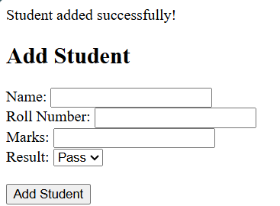
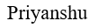
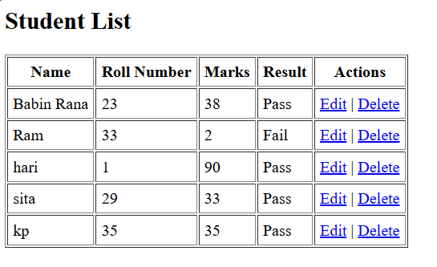

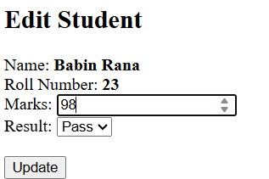


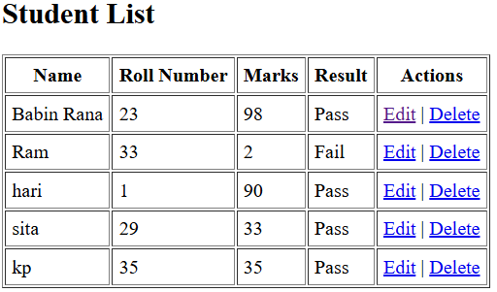


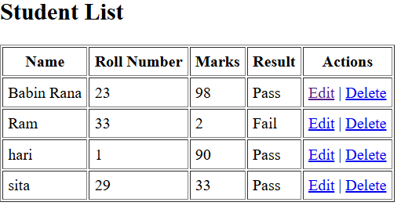


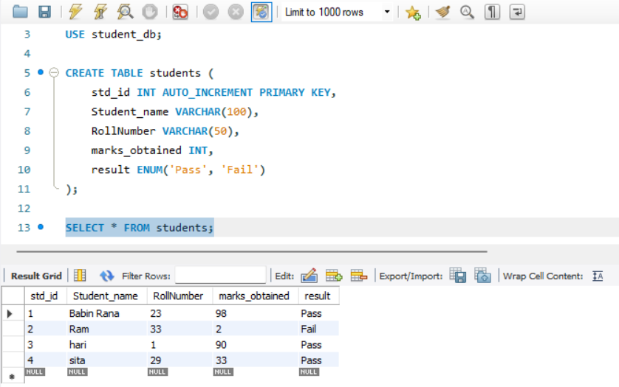

- In the above table:
a. Find the name of student with the highest marks
b. Find the name of student with lowest marks
c. Display the number of total students
d. Also show average marks obtained by the class

Code:
#highest marks
SELECT Student_name, marks_obtained
FROM students
ORDER BY marks_obtained DESC
LIMIT 1;

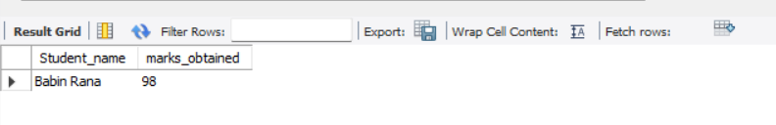
#lowest marks
SELECT Student_name, marks_obtained
FROM students
ORDER BY marks_obtained ASC
LIMIT 1;


#total number of students
SELECT COUNT(*) AS total_students
FROM students;
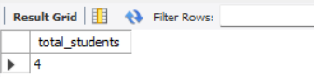
#avg marks
SELECT AVG(marks_obtained) AS average_marks
FROM students;


- Display the result in ascending order and also find the number of students that have passed and
failed using order by.

Code:
#result in ascending
SELECT *
FROM students
ORDER BY marks_obtained ASC;


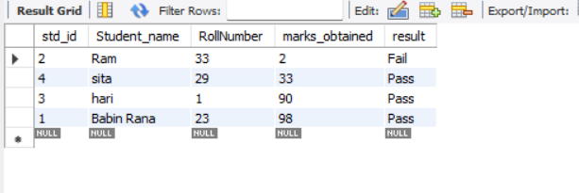

#number of student passed and failed
SELECT result, COUNT(*) AS total
FROM students
GROUP BY result
ORDER BY result ASC;
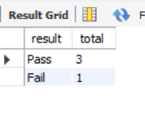

- Demonstrate the role of joins in MYSQL. Create another table with student address and parents
name, mobile phone, email. Display the parents name and email of the students who have
failed the exam.

Code:
CREATE DATABASE student_db;

CREATE TABLE student_details (
std_id INT,
parent_name VARCHAR(100),
mobile_phone VARCHAR(15),
email VARCHAR(100),
address VARCHAR(255),
FOREIGN KEY (std_id) REFERENCES students(std_id)
);

SET SQL_SAFE_UPDATES = 0;

DELETE FROM students;
DELETE FROM student_details;

INSERT INTO students (std_id, Student_name, RollNumber, marks_obtained, result)
VALUES
(1, 'Babin', 101, 78, 'Pass'),
(2, 'Shuvam', 102, 45, 'Fail'),
(3, 'Priyanshu', 103, 30, 'Fail'),
(4, 'Nischal', 104, 89, 'Pass'),
(5, 'Sandesh', 105, 60, 'Pass');

INSERT INTO student_details (std_id, parent_name, mobile_phone, email, address)
VALUES
(1, 'Mr. Thapa', '9849627144', 'thapaliya@email.com', 'Kathmandu'),
(2, 'Mrs. limbu', '9814441112', 'Mr.Shakya@gmail.com', 'Lalitpur'),
(3, 'Mr.Shrestha', '9808146213', 'Mr.Shrestha@gmail.com', 'Bhaktapur'),
(4, 'Mrs.Sharma', '98863822', 'Sharma.par@email.com', 'Kathmandu'),
(5, 'Mrs. Raj', '9869008722', 'rajyalaxmi@email.com', 'Pokhara');

SELECT
s.Student_name,
sd.parent_name,
sd.email
FROM
students s
JOIN
student_details sd ON s.std_id = sd.std_id
WHERE
s.result = 'Fail';

Output:





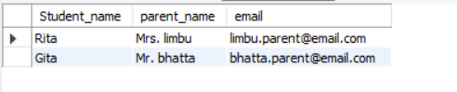

5. Demonstrate how OOP is used in PHP. Show how we can use constructor and destructor in PHP

Code:
#constructor
<?php
class Car {
public $model;
public $color;
// Constructor
public function __construct($model, $color) {
$this->model = $model;
$this->color = $color;
}

public function display() {
echo "Model: $this->model, Color: $this->color";
}
}
$myCar = new Car("Tesla", "Red");
$myCar->display();
?>

Output:

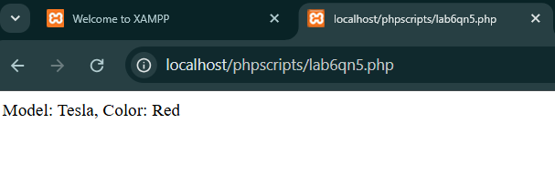
#destructor
<?php
class Database {
public $connection;
// Constructor to initialize the connection
public function __construct($hostname) {
$this->connection = "Connected to database at $hostname";
echo $this->connection;
}

public function __destruct() {
echo "\nConnection closed.";
}
}

$db = new Database("localhost");
?>

Output:

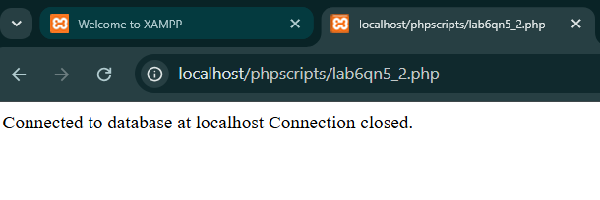

6. Create a Parent Class Lecturer. Derive two children class Parttime and Fulltime. The children class must share at least 2 properties each with parent class. Show case the working of inheritance and polymorphism in PHP

Code:

<?php

class Lecturer {

public $name;
public $subject;

public function __construct($name, $subject) {
$this->name = $name;
$this->subject = $subject;
}

public function displayInfo() {
echo "Lecturer Name: $this->name <br>";
echo "Subject: $this->subject <br>";
}

public function calculateSalary() {
echo "Salary Calculation (general method) for Lecturer: Not defined yet. <br>";
}
}

class Parttime extends Lecturer {
public $hoursWorked;

public function __construct($name, $subject, $hoursWorked) {
parent::__construct($name, $subject); // Call parent constructor
$this->hoursWorked = $hoursWorked;
}

public function calculateSalary() {

$hourlyRate = 20; // Assume hourly rate
$salary = $this->hoursWorked * $hourlyRate;
echo "Parttime Lecturer Salary: $$salary for $this->hoursWorked hours worked. <br>";
}
public function displayParttimeDetails() {
$this->displayInfo(); // Call the parent method
echo "Hours Worked: $this->hoursWorked <br>";
}
}

class Fulltime extends Lecturer {

public $fixedSalary;

public function __construct($name, $subject, $fixedSalary) {
parent::__construct($name, $subject); // Call parent constructor
$this->fixedSalary = $fixedSalary;
}

public function calculateSalary() {

echo "Fulltime Lecturer Salary: $$this->fixedSalary (fixed salary). <br>";
}
public function displayFulltimeDetails() {
$this->displayInfo(); // Call the parent method
echo "Fixed Salary: $$this->fixedSalary <br>";
}
}

$parttimeLecturer = new Parttime("Spencer Shrestha", "Mathematics", 20); // 20 hours worked
$fulltimeLecturer = new Fulltime("Spency Kumar", "Science", 15000); // $15000 fixed salary

$parttimeLecturer->displayParttimeDetails();
$parttimeLecturer->calculateSalary();

$fulltimeLecturer->displayFulltimeDetails();
$fulltimeLecturer->calculateSalary();

?>

Output:
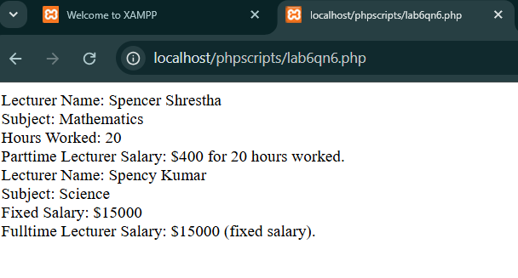

Lab 7:

Lab 7:

- In the above question use different access modifiers to show their use case. Make use of setter and getter functions to access private and public properties

Code:

<?php

class Lecturer {

public $name;
public $subject;

protected $universityName;

private $salary;

public function __construct($name, $subject, $universityName, $salary) {
$this->name = $name;
$this->subject = $subject;
$this->universityName = $universityName;
$this->salary = $salary;
}

public function getSalary() {
return $this->salary;
}

public function setSalary($salary) {
$this->salary = $salary;
}

public function getUniversityName() {
return $this->universityName;
}

public function displayInfo() {
echo "Lecturer Name: $this->name <br>";
echo "Subject: $this->subject <br>";
}

public function calculateSalary() {
echo "Salary Calculation (general method) for Lecturer: Not defined yet. <br>";
}
}
class Parttime extends Lecturer {

public $hoursWorked;

public function __construct($name, $subject, $universityName, $salary, $hoursWorked) {
parent::__construct($name, $subject, $universityName, $salary); // Call parent constructor
$this->hoursWorked = $hoursWorked;
}

public function calculateSalary() {

$hourlyRate = 20; // Assume hourly rate
$salary = $this->hoursWorked * $hourlyRate;
echo "Parttime Lecturer Salary: $$salary for $this->hoursWorked hours worked. <br>";
}

public function displayParttimeDetails() {
$this->displayInfo();
echo "University: " . $this->getUniversityName() . "<br>";
echo "Hours Worked: $this->hoursWorked <br>";
}
}

class Fulltime extends Lecturer {
private $fixedSalary;

public function __construct($name, $subject, $universityName, $salary, $fixedSalary) {
parent::__construct($name, $subject, $universityName, $salary); // Call parent constructor
$this->fixedSalary = $fixedSalary;
}

public function calculateSalary() {

echo "Fulltime Lecturer Salary: $$this->fixedSalary (fixed salary). <br>";
}

public function displayFulltimeDetails() {
$this->displayInfo(); // Call the parent method
echo "University: " . $this->getUniversityName() . "<br>";
echo "Fixed Salary: $$this->fixedSalary <br>";
}

public function getFixedSalary() {
return $this->fixedSalary;
}

public function setFixedSalary($salary) {
$this->fixedSalary = $salary;
}
}

$parttimeLecturer = new Parttime("Priyanshu Shrestha", "Mathematics", "Asian University", 5000, 16);
$fulltimeLecturer = new Fulltime("Raka Maharjan", "Science", "AB University", 5200, 5800);

$parttimeLecturer->displayParttimeDetails();
$parttimeLecturer->calculateSalary();

$fulltimeLecturer->displayFulltimeDetails();
$fulltimeLecturer->calculateSalary();

echo "Before Update: Fulltime Lecturer Salary: " . $fulltimeLecturer->getSalary() . "<br>";

$fulltimeLecturer->setSalary(6000);
echo "After Update: Fulltime Lecturer Salary: " . $fulltimeLecturer->getSalary() . "<br>";

?>

Output:
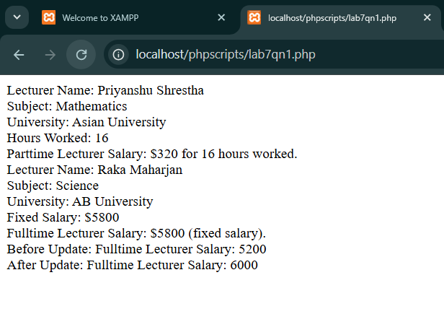

- What are static members? WAP to show the use of static members in OOP
Ans: In Object-Oriented Programming, static members (properties or methods) belong to the class itself rather than any specific object.
You can access them without creating an object of the class using ClassName:: syntax.
Code:
<?php

class Student {

private static $studentCount = 0;

public $name;

public function __construct($name) {
$this->name = $name;
self::$studentCount++; // Increase count when object is created
}

public static function getStudentCount() {
return self::$studentCount;
}
}

$student1 = new Student("Priyanshu");
$student2 = new Student("Shuvam");
$student3 = new Student("Raka");
$student4 = new Student("Md Mojibul");

echo "Total Students: " . Student::getStudentCount();

?>

Output:
